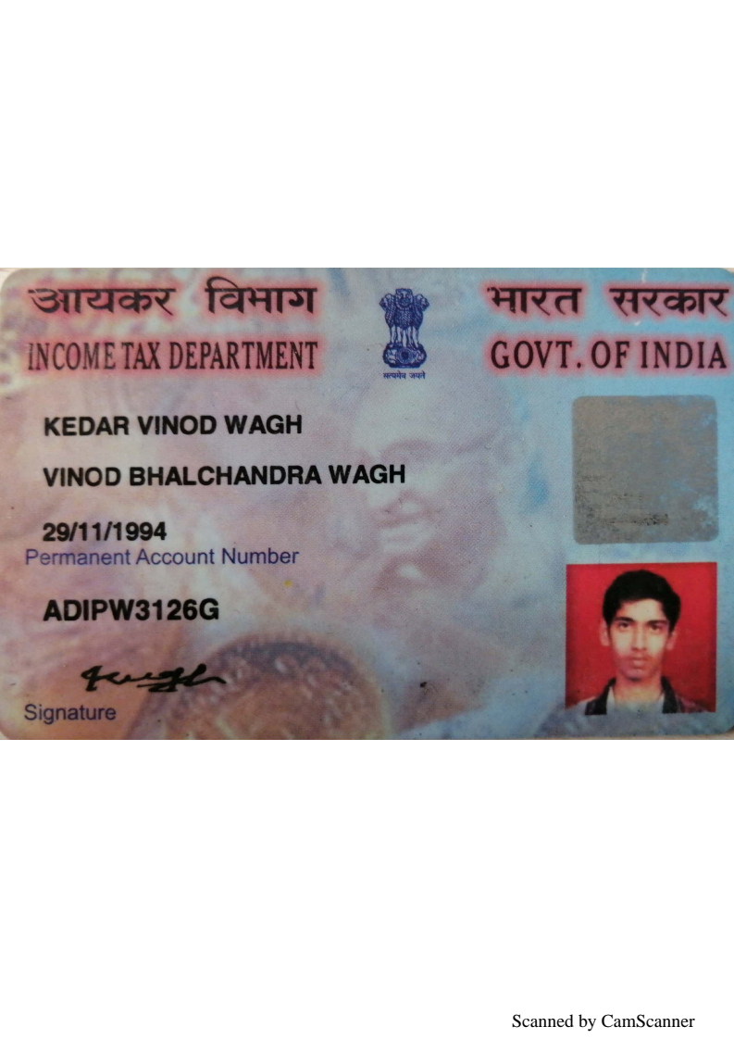

Candidate's Full Legal Name (as it appears on PAN)Vishal Nikam | Kedar Wagh
Supplier Name (Registered Name) | People-prime Worlwide
Worked for CG previously? (IF yes share CG  Employee ID/GGID required | No
JOB Posting ID | CGEMJP00348439
Contact No (10 Digit No) | 8605422992
Email ID | kdrwagh@gmail.com
Job Location (Work Location)
Notice Period (Immediate/ Notice to Serve) | Pune
Highest Education (Regular or Distance) | B. E
Employment Detail – Last 2 yrs Working period  (Payroll Company) | Einfochips
College & University Full Name - | Pune University
Mandatory Skills & Experience  (quick checklist – verify each skill, years of  experience) | TOTAL EXPERIENCE- 10 Years  Uipath – 5 Years
“Secondary” Skills & Experience | VB.Net– 5Years
Key Remarks (Supplier Comment) | Candidate Good at Communication Skill. He has experience of 10 years.

Kedar Wagh
RPA Developer | UiPath Certified Automation Developer Associate
kdrwagh@gmail.com • 8605422992 • Pune, India • linkedin.com/in/kedar-wagh29

Professional Summary

Certified UiPath RPA Developer with 4+ years of experience in end-to-end process and test automation across enterprise applications. Specialised in UiPath Studio, Orchestrator (multi-tenant, high availability), REFramework, Document Understanding, and intelligent automation using AI Center and ML Extractors.
Proven track record in SAP, PDF, Excel, REST/SOAP API, and database automation with expertise in Orchestrator deployment, CI/CD integration via Azure DevOps, secure credential management, bot lifecycle management, and production support.

Core Skills

UiPath Studio • Orchestrator (Multi-tenant, HA) • REFramework • Document Understanding • AI Center • Test Suite • UiPath Apps • Action Center • SAP GUI Automation • REST/SOAP API Integration • SQL Server • Python • Git • Azure DevOps • Azure Key Vault • Power BI • Excel Automation • PDF Automation • State Machines • Parallel Execution

Work Experience

Senior Engineer | Einfochips | Pune
Oct 2021 – June 2026
- Designed and deployed end-to-end unattended and attended bot automations using UiPath Studio with REFramework, State Machines, and Parallel Execution across enterprise applications
- Configured and managed UiPath Orchestrator in multi-tenant environments including folder structure, user roles, machine templates, robot provisioning, high availability setup, and asset governance
- Managed Orchestrator queues, triggers, schedules, assets, and environments; monitored bot execution and performed issue analysis to maintain SLA and high availability
- Automated Vendor Invoice Processing in SAP using GUI automation, handling Vendor Code, PO Number, Invoice Date, Amount, Tax Code, and Line-Item details
- Implemented UiPath Document Understanding Framework for intelligent extraction from structured and unstructured PDFs, integrating OCR engines (Microsoft/Tesseract) and ML Extractors for document classification and data validation
- Built and consumed REST/SOAP API integrations within automation workflows to interact with external systems and legacy platforms
- Developed database automations using SQL queries and stored procedures against SQL Server databases; integrated results into automated reporting workflows
- Automated Excel operations including data extraction, transformation, validation, and reporting using UiPath Excel and Data Service activities
- Implemented secure credential management using Orchestrator Assets and CyberArk/Azure Key Vault integrations to enforce governance and audit compliance
- Maintained source control using Git with branching strategies; contributed to CI/CD pipelines using Azure DevOps for automated deployment of bot packages
- Created and executed UiPath Test Suite test cases for regression, functional, and smoke testing; published and monitored test schedules on Orchestrator
- Implemented robust exception handling, retry mechanisms, and structured logging; used Orchestrator logs and Robot logs for troubleshooting and root cause analysis
- Conducted code reviews, enforced REFramework best practices, and mentored junior RPA developers on development standards and debugging techniques
- Collaborated with business stakeholders and QA teams to gather automation requirements, document process maps, and ensure quality delivery

Technical Support Engineer | Peel-Works | Pune
Mar 2019 – Feb 2021
- Performed end-to-end functionality, regression, sanity, and smoke testing for new releases
- Identified and documented bugs with priority levels in Atlassian Jira; tracked issues through to developer resolution
- Escalated potentially impactful situations to senior management and provided solutions to customers within SLA
- Developed and published operational dashboards to track bug trends, SLA compliance, and release quality metrics, supporting data-driven decisions by senior management
- Advised clients on configuration options based on best practices; supported customers via email, chat, and phone
Supply Chain Executive | Speciality Sintered Products Pvt. Ltd. | Pune
Jun 2016 – Jan 2019
- Responsible for capacity and load management; managed in-house logistics for all production lines
- Monthly scheduling of supplier partners and advance planning for capacity assessment
- Developed and maintained escalation processes to ensure continued quality and timely delivery of supply
- Established and maintained supplier performance metrics (cost, delivery, quality, innovation) with the sourcing team

Education

Bachelor of Engineering – Mechanical Engineering | Pune University
Jun 2012 – Jun 2016

Certifications

UiPath Certified Automation Developer Associate – UiPath | Mar 2026

